for
Flame Safe
Mr. Louis Jacobini
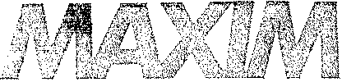
Maxim Tech.· Southwestern Labs 2200 Gravel Drive
Fort Worth. TX 76118-7123
TECHNOLOGiES iNC
Telephone: (817) 284-7755 Metro: (817) 589-7211 Fax: (817) 589-1420
FIRE HAZARD EVALUATION USING THE MONSANTO TWO - FOOT FLAME TUNNEL
AND
SMOKE CHAMBER
Performed on
April 22, 1997
Report No. 720380
Fort Worth, Texas

Asteco Q Austin Research Enqineers > Chen-Northern- Empire Soiis Investigations. Kansas City Testing
Maxim Engineers. Nebraska Testing· Patzig Testing 0 Southwestern Laboratories c Thornas-Hanip - Twin City

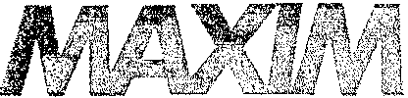
Maxim Tech. • Southwestern Labs 2200 Gravel Drive
Fort Worth, TX 76118-7123
TECHNOLOGIES INC
Telephone: (817) 284-7755 Metro: (817) 589-7211 Fax: (817) 589-1420
FIRE HAZARD EVALUATION USING THE MONSANTO TWO-FOOT FLAME TUNNEL AND SMOKE CHAMBER
SAMPLE IDENTIFICATION:
- Plywood
- White Wood 20 (2" x 4")
SCOPE OF TESTING:
The purpose of this testing was to determine the protection a material affords its substrate and the comparative burning characteristics of coatings. The testing was accomplished using equipment and procedures to evaluate the flame spread over the surface of the material under controlled conditions. This establishes a basis for comparing surface-burning characteristics of different coatings without specific consideration of all the end-use parameters that might affect these characteristics under actual fire conditions.
In addition to the predicted flame spread rate, the afterflame time, afterglow time/ smoldering and smoke developed rate may be measured. However, a relationship should not be presumed among these measurements.
SIGNIFICANCE:
A number of laboratory procedures are used in evaluating the effectiveness of fire-retardant and fire-resistant treatments and coatings. In general these methods measure the three stages of fire development: (1) ignition, (2) flame spread (rate of growth of the fire), and (3) conflagration extent. While all three are of extreme importance; flame spread has been recognized as the main factor associated with testing fire-retardant coatings. The Two-Foot Tunnel apparatus as produced by the Monsanto Company has been designed specifically to predict the performance by the ASTM E-84 (Steiner Tunnel) equipment. Flame spread ratings based upon ASTM E-84 have acquired common acceptance regulatory agencies, but such large scale tests are seldom practical during the development or modification of a fire-retardant coating.
Asteco o Austin Research E:nclineers" Chen-Northern" Empire Soils Investigations. Kansas City Testing
Maxim Engineers < Nebraska Testing. ·Patzig Testing· Southwestern Laboratories 0 Thomas-Hartig· Twin City Testing

The Monsanto Two-Foot Flame Tunnel and Smoke Chamber consists of a 24 x 4 inch angle-iron flame lined 28° from the horizontal. The sides and fire-end of the tunnel are covered with 1/4" asbestos-cement board which is attached to the inside of the frame. The open end, flue end and cutout sides allow a natural draft through the tunnel. Heat, gases and smoke rise by convection flow. The sample holder is notched along the bottom, or supporting lip angle at one inch intervals to assist in measurement of the flame advance. An observation window, a two-- inch wide strip of 1/8" polished vycor plate, is located just below the sample holder and extending the full length of the tunnel. The glass is calibrated every inch from 4 to 22. The burner, using local commercial gas fuel, is placed 2 1/4¹¹ horizontally from the interior of the fire-end of the tunnel. A thermocouple, ignition transformer, t and regulating valve are part of the assembly.
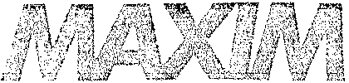
TECHNOI.OGIES INC
This method provides the relative flame spread In comparison with standard materials. Results from the two-foot tunnel test have been shown to correlate to a predicted approximate ASTM E- 84 result, according to the following equation:
y = 4.8 + O.92x
where x is the result obtained from the Monsanto test apparatus and y is the predicted result from ASTM E-84.
Degree of the density of the smoke, particulate matter, and other effluent given off by the test specimen are continuously recorded during the flame spread test and rated as a percentage of the degree of smoke density of red oak. Comparative smoke density determinations are made by use of the Monsanto Smoke Chamber which was developed as an approximation of the smoke density equipment utilized in the ASTM E-84 equipment. No direct correlation data is available between smoke density results obtained by the Monsanto Chamber and those obtained by ASTM E-84.
TEST EQUIPMENT:
The Smoke Chamber is equipped with a light source, photoelectric cell, milliampere recorder, necessary stacks, vents and accessories.
Test results are shown on the following page.
Asteco • Austin Research Engineers· Chen-Northern' Empire Soils Investigations. I<ansas City Testing
Maxim Engineers" Nebraska Testing G Patzig Testing· Southwestern Laboratories • Thomas-Hartig· Twin City Testing

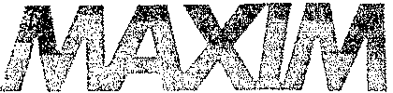
TECHNOLOGIES !NC
TEST RESULTS: Pl}~ood, PI, 2 and 3
Test and Calibration Data:
Tunnel is calibrated prior to each day's operation by determining the difference in flame length of standard preconditioned mineral board and red oak boards.
Data
Calibration Panels Mineral
Red Oak Board
Test Specimen No.1 No.2 No.3
Flame Length (L) (Average of three highest consecutive flame front readings)
17.3
8.5
10.0 10.1 9.5
Flame Spread (FS) (Flame length of test panel minus flame length of mineral board calibration panel)
1.5 1.6 1.0
Flame Spread Constant (k)
(I 00) Lo - La
( 100 (17.3-8.5)
= 11.36
EVALUATION OF TEST DATA:
Determination
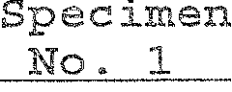
Test Specimen No. 2
Test*
Specimen
No. 3 Avg
Test
Monsanto Flame Spread Rat (FS multiplied k)
17.0
18.2
11.4
15.5
FLAME SPREAD - Predicted
E-84 value by use of
Monsanto formula
20.4
21. 5
15.3
19.1
Smoke Developed Rating 44.00
Reported as a percentage
of smoke developed by
the Red Oak Calibration Panel
68.75
137.50
83.42
*Knot in Burn Areas

Asteco • Austin Research Engineers' Chen-Nonhem > Empire Soils investigations· Kansas City Testing
Maxlm Engineers. Nebraska Testing. Patzig Testing 4 Southwestern Laboratories » Ihornas-Harfiq > Twin City Testing

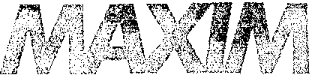
TECHNOI.OGIES iNC
TEST RESULTS: White Wood 20 2" x 4" At B, C
Test and Calibration Data:
Tunnel is calibrated prior to each day/s operation by determining the difference in flame length of standard preconditioned mineral board and red oak boards.
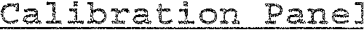
Mineral Board
Test Snecimen No,A No.B No.C
Data
Red Oak

Flame Length (L) (Average 17.3
of three highest consecu-
tive flame front readings)
8.5
10.0 9.25 9.75

Flame Spread (FS)(Flarne length of test panel minus flame length of mineral board calibration panel)

1.5 0.75 1.25

Flame Spread Constant (k)

(100) Lo - La

( 100 (17.3-8.5)
)
= 11.36
EVALUATION OF TEST DATA:
Test
Determination
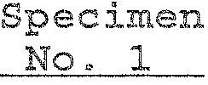
Test Specimen No. 2
Test*
Specimen
No.3 Avg.

Monsanto Flame Spread Rating (FS multiplied by k)

17.0

8.5
14.2 13.2

FLAME SPREAD - Predicted E 84 value by use of Monsanto formula

20.4

12.6
17.9 17.0
Smoke Developed Rating 62.5

Reported as a percentage

of smoke developed by

the Red Oak Calibration Panel

62.5

62.5

62.5
Asteco 0 Austin Research Engineers· Chen-Northern" Empire Soils lnvestiqations » Kansas City Testing
Maxim Engineers. Nebraska Testing Patzig Testing· Southwestern Laboratories e Thomas-Hartiq- Twin City Testing

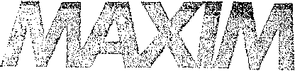
TECHNOLOGIES INC
Note:
This test report contains only findings and results arrived at after employing the specified procedures listed herein. These findings and results apply only to the submitted sample or samples. s test report is not intended to constitute a recommendation for, or endorsement of, the product or material tested.
References:
ASTM D3806, Small-scale Evaluation of Fire Retardant Paints (Two-Foot Tunnel Method)
ERDL Report No. 1226, Report No. 111939 Department of Commerce Vandersall, H.L., Journal of Paint Technology, Volume 39/ No. 511494, Interior Federal Specification TT-P-00193Z (GSA-FSS) Harland, W.J. Journal of Paint Technology, Vol. 44, No. 57564.
Technician:
Les Hall
Sincerely,
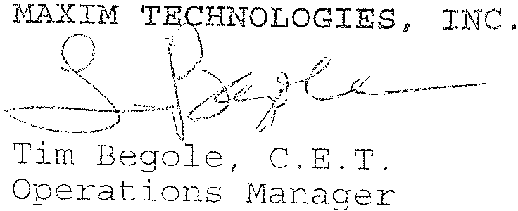
bf
Asteco e Austln Research Engineers. Chen-Northern 0 Empire Soils Investigations' Kansas City Testing
Maxim Engineers. Nebraska Testing c Patziq Testing" Southwestern Laboratories • Thomas-Hartiq » Twin City Testing

